**Mentor and Student Assigning with Database**

1. Write API to create Mentor

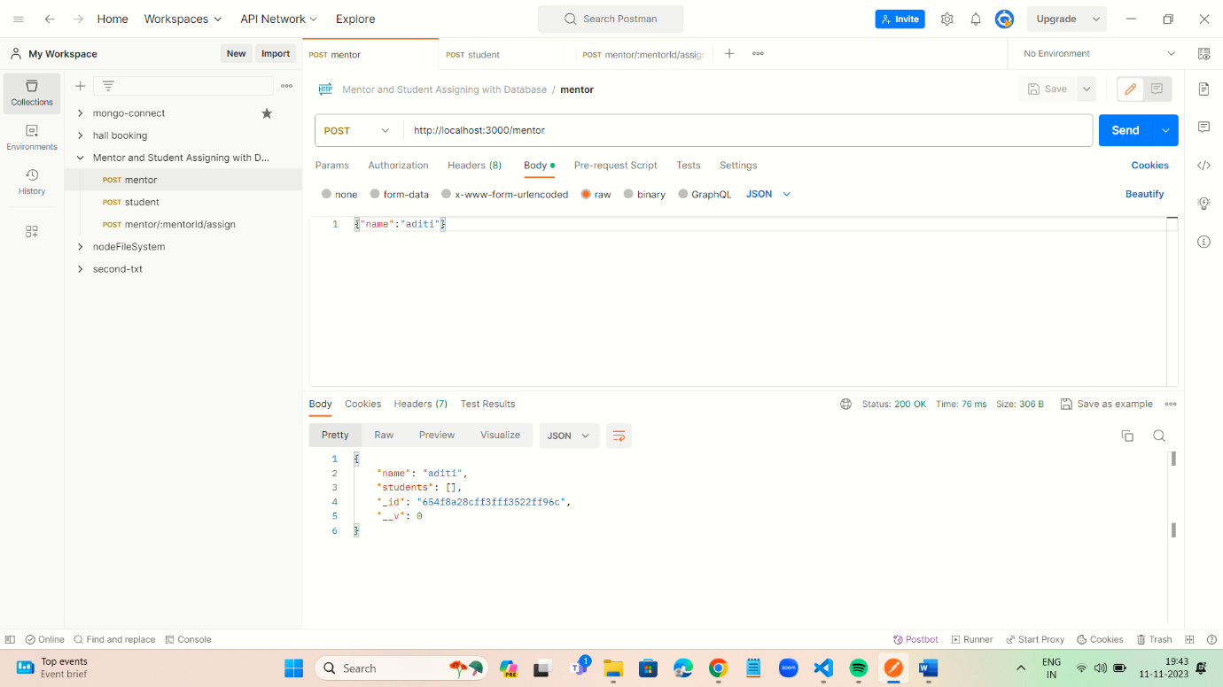

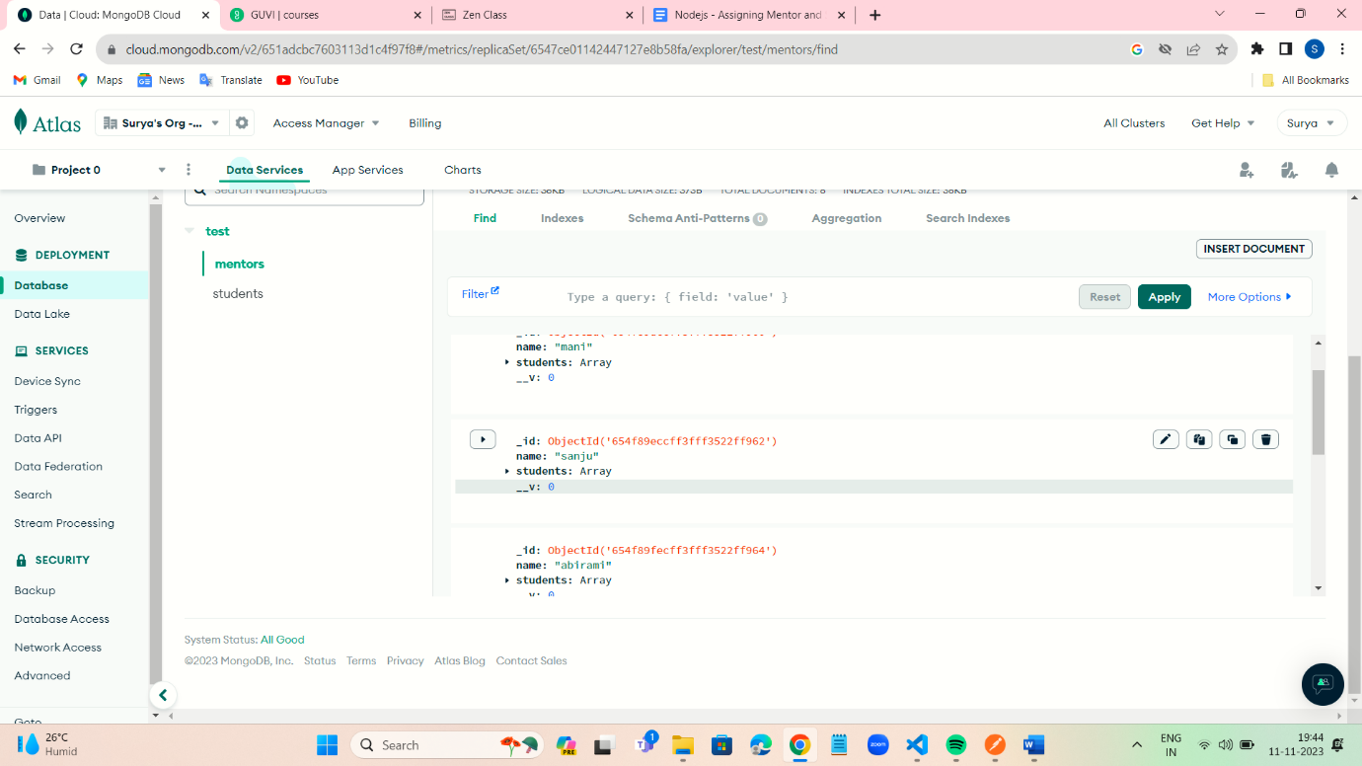

1. Write API to create students

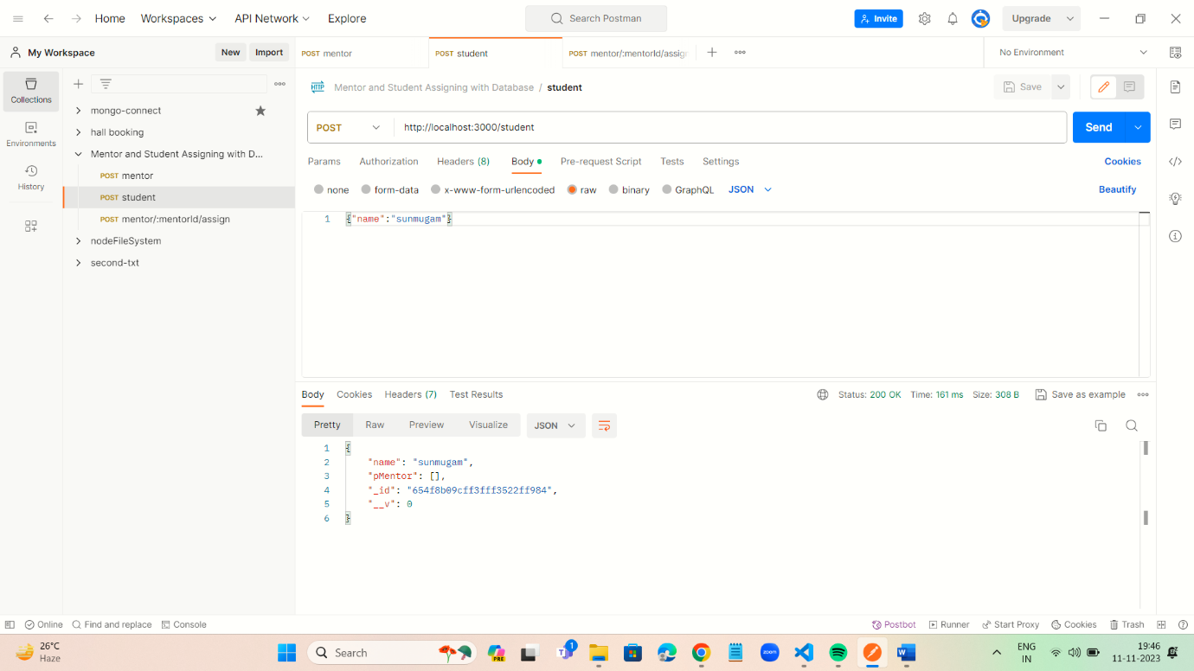

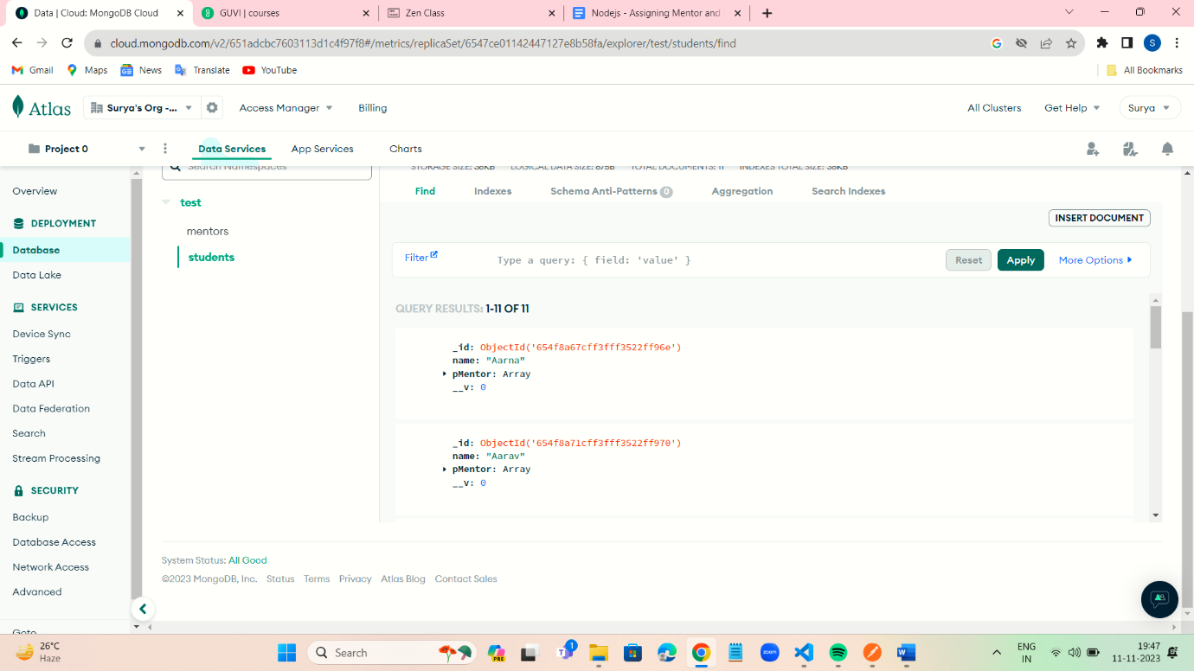

1. Write API to Assign a student to Mentor

* Select one mentor and Add multiple Student
* A student who has a mentor should not be shown in List

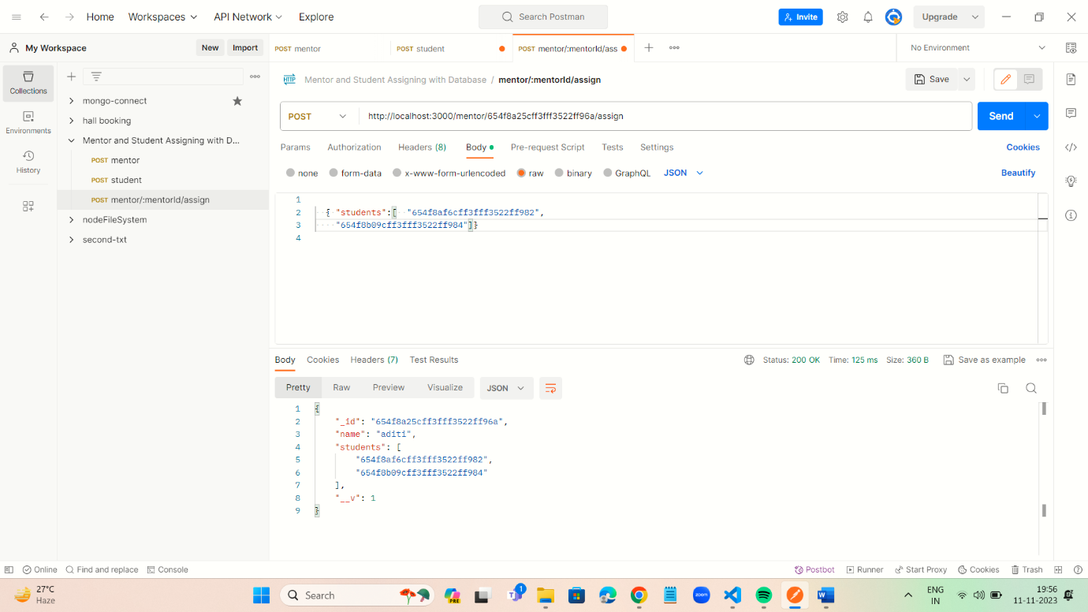

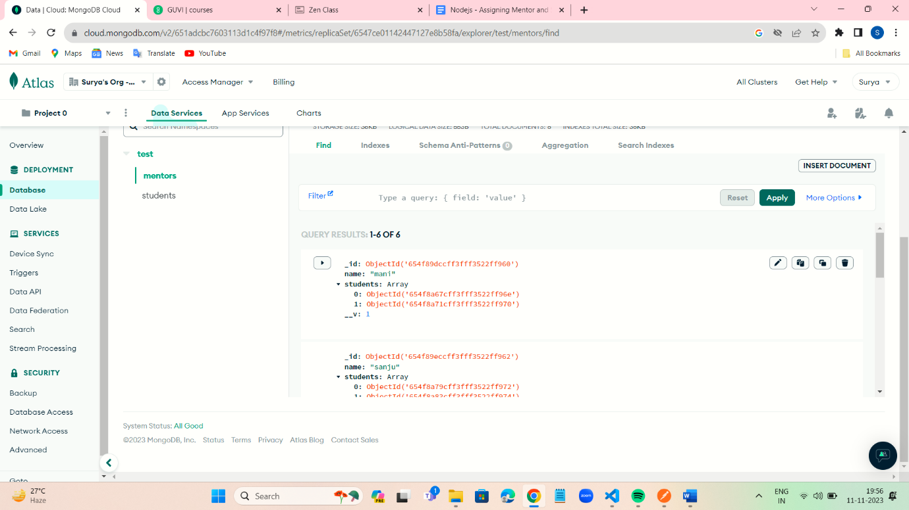

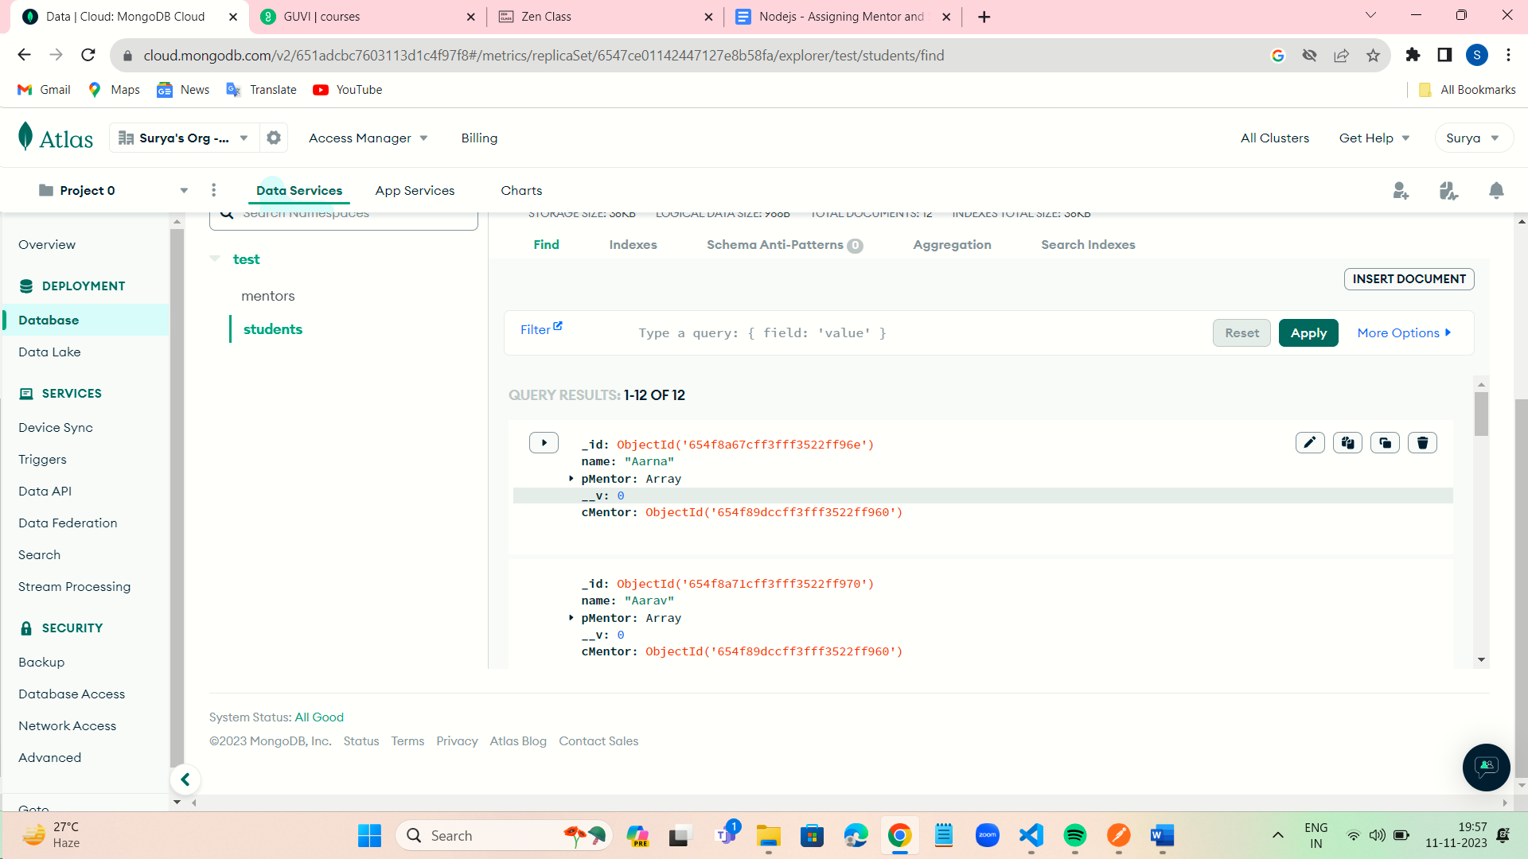

4.Write API to Assign or Change Mentor for particular Student

* Select One Student and Assign one Mentor

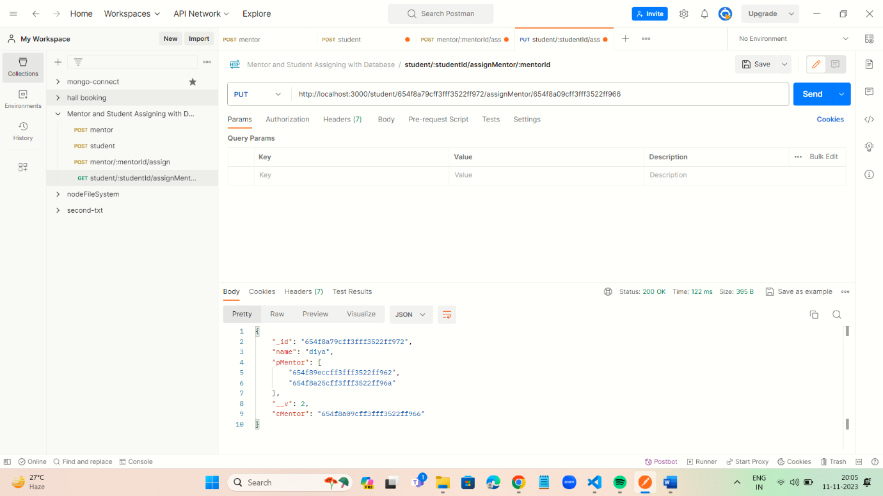

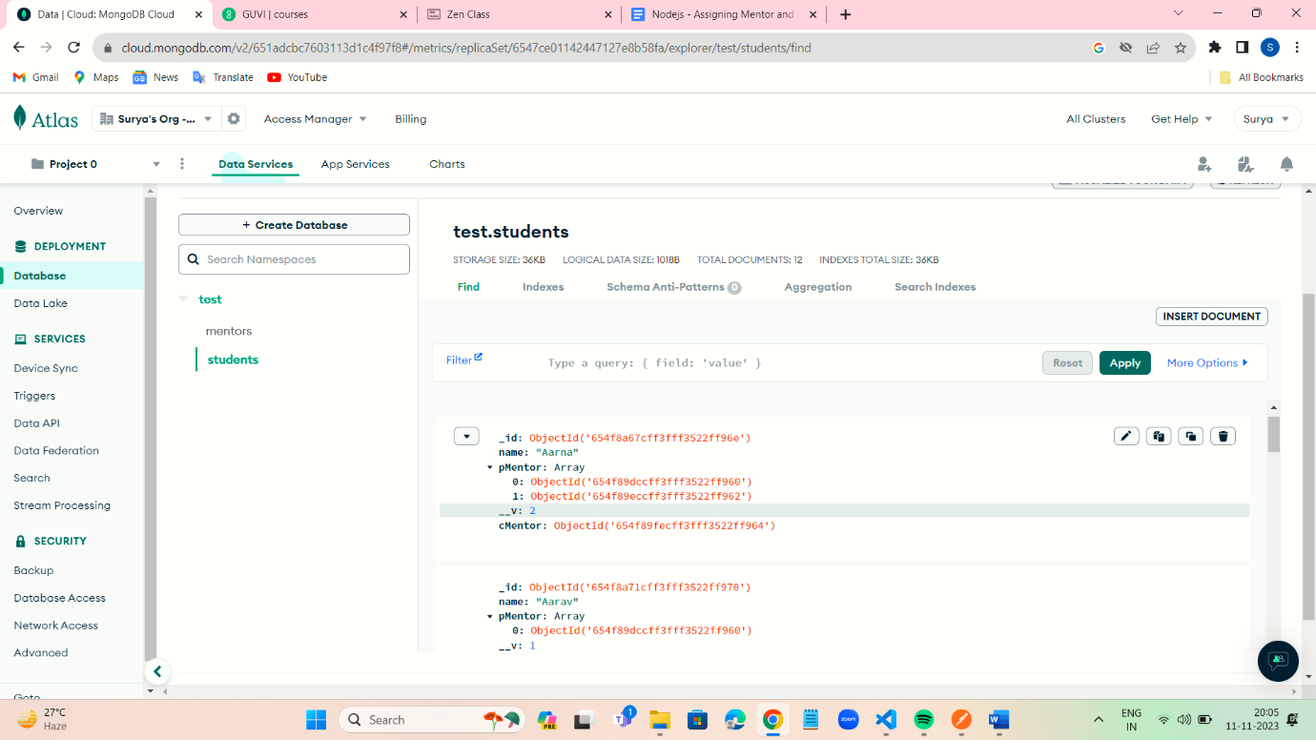

5.Write API to show all students for a particular mentor

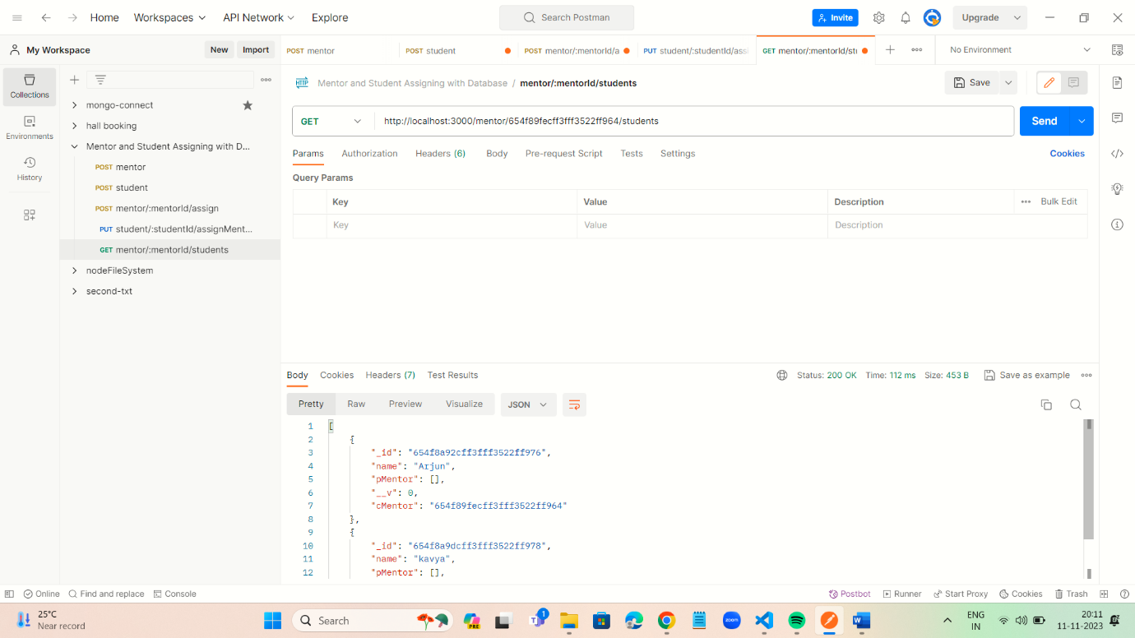

6.Write an API to show the previously assigned mentor for a particular student.

